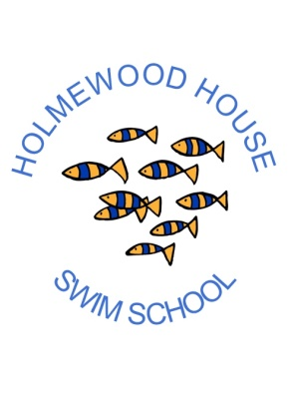
HOLMEWOOD HOUSE SWIM SCHOOL
MEDICAL INFORMATION FORM
It would be a great help to the swimming instructors and for the safety of your child if you could detail any medical conditions that the person named below might suffer from, including learning difficulties.

Name:
Suffers from (please give details):

Are there any other problems that may affect their swimming ability and which you believe would help the swimming instructor to know about? Do you have any strateges which may help us to help your child?

Don’t forget to let us know if any condition changes or new ones develop.
Signed:
Date:
Please return this form to the Holmewood House Swim School, Langton Green, Tunbridge Wells, TN3 0EB prior to the commencement of the swimming lessons.

